Robots at the ready: Robotics conference championship at Cass Lake-Bena
CASS LAKE -- A regional robotics tournament today at Cass Lake-Bena High School will be the emerging sport's first formal conference championship in Minnesota, organizers say.

Written By: Joseph T. Bowen | 5:36 pm, Oct. 27, 2017 (Bemidji Pioneer)
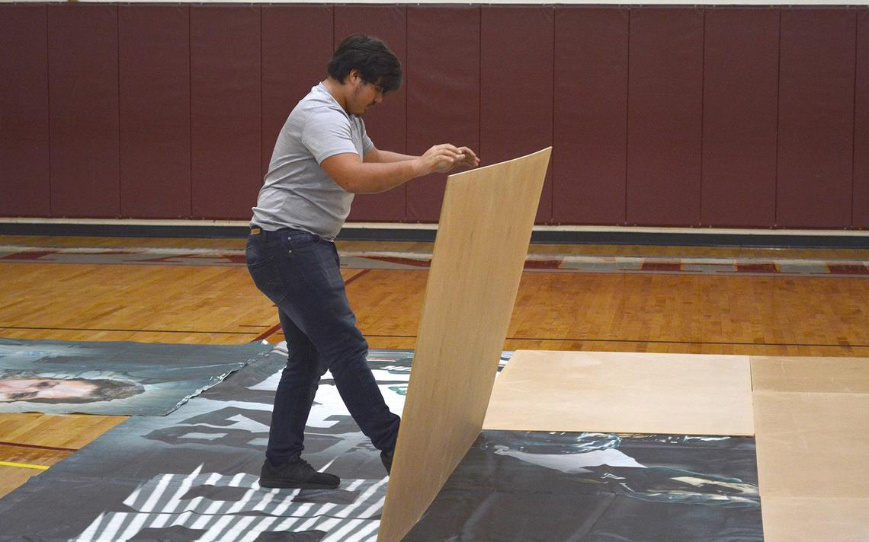
Cass Lake-Bena High School junior Hunter Kaasa lays wood tiles in the school gym on Thursday in preparation for the robotics conference championship. (Jordan Shearer | Bemidji Pioneer)
CASS LAKE -- A regional robotics tournament today at Cass Lake-Bena High School will be the emerging sport’s first formal conference championship in Minnesota, organizers say.
The Minnesota State High School League officially recognized last summer the Northern Minnesota Robotics Conference, a collection of nearly 20 Minnesota high school teams and one from North Dakota. Conference leaders have organized a championship on Saturday at the high school before a fresh round of worldwide competitions start in early 2018.
Every January, teams of students around the country learn what tasks their robot will be asked to complete for points in regional, state, and world competitions that year. The tournament this weekend will use January 2017 rules -- which challenged teams’ remote-controlled bots to climb a rope, haul gears, or fire whiffle balls at targets -- making it a warmup of sorts for the next competitive season.
“Our main goal is to show the maybe not-robotics people up in Northern Minnesota what we’re doing by having an event up here,” said Jesse Frost, the tournament’s field supervisor, president of the conference and coach of both CL-B teams. “We kind of want to make it more than just like a scrimmage or a pre-event.”
Teams there will represent school districts and charters from Bemidji, Nevis, Thief River Falls, Blackduck, Badger, and, of course, Cass Lake-Bena, which has a boys’ and girls’ team. Red Lake High School is reportedly forming a team this year, as well.
The event is free and open to the public and doors open at 7 a.m. at the Cass Lake-Bena High School Gym.
If you go:
What: Northern Minnesota Robotics Conference championship
When: Doors open at 7 a.m.; opening ceremonies begin at 8:30 a.m. today
Where: Cass Lake-Bena High School gym, 15308 State Highway 371 NW, Cass Lake

